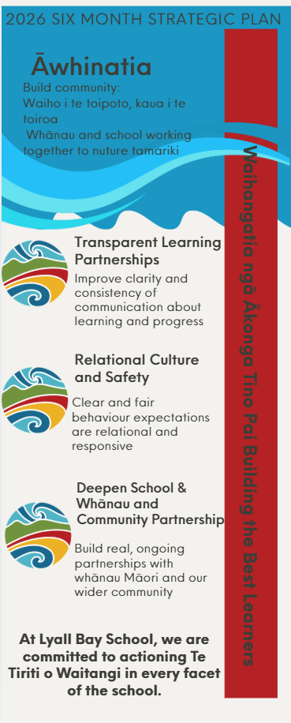 | 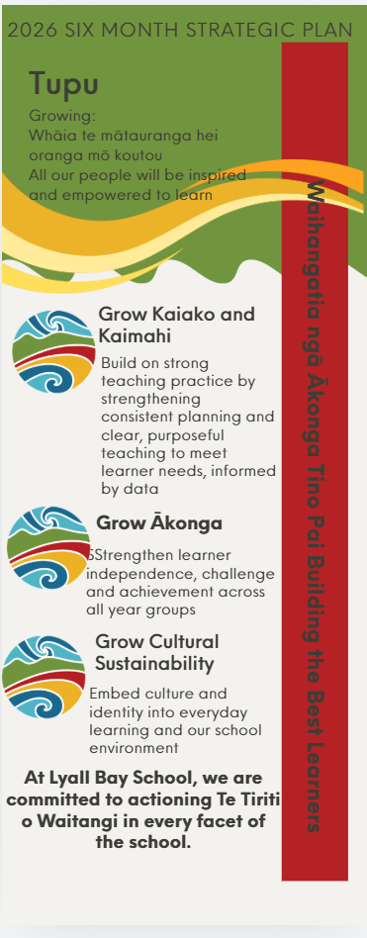
Strategic Six-Month Plan
Āwhinatia — Building Community Waiho i te toipoto, kaua i te toiroa — Whānau and school working together to nurture tamariki
Transparent Learning Partnerships
Strategic Priority | Objective | Outcomes | Action | Measures | People
Improve clarity and consistency of communication about learning and progress | Education and Training Act 2020 127 (b)  127 (f), (f) iii | Whānau confidence and trust in learning partnerships increases | Twice termly ‘Learning Snapshots  Structure of Learning Conversations reviewed  Structure of Timely Comments in reporting | By the end of Term 2:  - A mid-year whānau pulse survey will measure confidence in understanding progress. | Leadership Team Principal Senior Leadership Team
Relational Culture and Safety
Strategic Priority | Objective | Outcomes | Action | Measures | People
Clear and fair behaviour expectations are relational and responsive | Education and Training Act 2020  127 (c) i, iii | Learners experience a safe, respectful, and responsive school culture | Gather ākonga voice regularly  Share Behaviour Response Framework and ensure it is enacted. | By the end of Term 2:  - Shared behaviour expectations will be documented and communicated school-wide.  - A clear behaviour response framework is in place, understood by staff, and reviewed regularly to ensure fair and responsive practice.  - Behaviour data is analysed by SLT and reported to the Board at each meeting. | Leadership Principal
Deepen School–Whānau and Community Partnership
Strategic Priority | Objective | Outcomes | Action | Measures | People
Build real, ongoing partnerships with whānau Māori and our wider community | Education and Training Act 2020  127 (e ) i, iii | Relationships with whānau and community become stronger and more meaningful over time | Increase engagement opportunities with whānau Māori | - Whānau engagement indicators — increased attendance.  - Evidence of partnership initiatives embedded within school programme. | Senior Leadership Team Kaiako
Tupu — Growing Whāia te mātauranga hei oranga mō koutou — All our people will be inspired and empowered to learn
Grow Kaiako and Kaimahi
Strategic Priority | Objective | Outcomes | Actions | Measures | People
Build on strong teaching practice by strengthening consistent planning and clear, purposeful teaching to meet learner needs, informed by data | Education and Training Act 2020  127 (f) i, ii | Teaching across the school continues to be consistent, purposeful and responsive to learner needs. | Provide professional learning in English, Mathematics & Statistics, and data-informed practice to support meeting learner needs  Undertake regular leadership walkthroughs to support consistent teaching practice  Strengthen collaborative planning within teams to ensure shared expectations | By the end of Term 2:  - Leadership walkthroughs indicate increasing consistency in planning, teaching practice, and use of data.  - Planning documentation reflects shared expectations for teaching and learning.  - Staff survey data indicates increasing confidence in shared expectations and practices | Kaiako Senior Leadership
Grow Ākonga
Strategic Priority | Objective | Outcomes | Actions | Measures | People
Strengthen learner independence, challenge and achievement across all year groups | Education and Training Act 2020  127 1, 2 (a) | Learners demonstrate increasing independence, engagement, achievement and regular attendance | Provide professional learning to strengthen Learning Through Play, learner independence, and expectations for achievement  Design engaging programmes of learning that promote independence, challenge and achievement  Monitor and respond to attendance through consistent school-wide approaches (including STAR) | By mid-year:  - Student voice indicates increased clarity of learning goals and engagement in learning.  - Mid-year progress data for priority learners indicates progress and is analysed and reported.  - Attendance data shows improved regular attendance, with targeted follow-up through the STAR process | Senior Leadership Principal
Grow Cultural Sustainability
Strategic Priority | Objective | Outcomes | Actions | Measures | People

Embed culture and identity into everyday learning and our school environment | Education and Training Act 2020  127 2 (c ) i, ii, iii  (d) | Learners feel a stronger sense of who they are and where they belong | Provide Professional Development through Kura Ahurea and M.A.C  Agreed strategies and cultural narratives are observed.  Gather voice of tamariki regarding identity and belonging. | By mid-year:  - Staff participate in professional learning focused on teaching that reflects and respects students’ cultures.  - Classroom walkthroughs reflecting increased use of agreed strategies.  - Cultural narratives will be visible in learning environments.  - Tamariki voice will be gathered regarding identity and belonging. | Kaiako / Kura Ahurea Toa Leadership Principal

