Lyall Bay School Strategic Plan 2024-2025
Our Purpose Statement  Building the Best Learners  Waihangatia ngā Ākonga Tino Pai  To achieve educational excellence for each child through a partnership between the home, school and community. |  | Our Values
 |  | Manaaki  Whakapono  Pākiki  Hiranga | Respect  Integrity  Curiosity  Excellence
The New Zealand Curriculum  “Young people who will be confident, connected, actively involved, lifelong learners”.  This is achieved through teaching and learning based on the following… | Learning Areas  From the New Zealand Curriculum  - English  - Mathematics and Statistics  - Science  - Technology  - Social Sciences  - The Arts  - Health and Physical Education  - Learning Languages | Key Competencies  From the New Zealand Curriculum  - Thinking  - Relating to Others  - Using Language, Symbols, and Texts  - Managing Self  - Participating and Contributing

Profile
Lyall Bay School (established 1909) is situated in beautiful Lyall Bay, Wellington. We are a Yr 0-6 primary school, with an approximate roll of 340 students. Lyall Bay School students reflect the culturally rich and diverse community that we are part of.

Lyall Bay School has a proud history of providing quality learning and teaching programmes and seeking the best opportunities for our learners. We have a dedicated staff, who all contribute to the learning experiences and needs of our children. Staff work in collaboration to ensure learning programmes that are founded on sound and effective teaching practice.

As a school, we actively involve our community through a range of different events and opportunities. The school radio station MaranuiFM assists us to maintain our ongoing positive relationship with the local community. Whānau are also involved through sporting opportunities, learning and teaching programmes, cultural experiences, informal events and our open-door policy.

Lyall Bay School enjoys a very active ‘Friends of Lyall Bay’ team, who are the primary fundraising source for the school.

We are incredibly proud of our school where we all work together as a team – ‘Waihangatia ngā Ākonga Tino Pai Building the Best Learners’

Our Cultural Diversity
Our goal is to develop and maintain programmes and an ethos that reflects New Zealand’s cultural diversity and, in particular, the unique position of Māori as the tangata whenua. When developing policies and practices for the school, every endeavour is made to reflect New Zealand’s cultural diversity, as well as being inclusive of all cultures within our school and community. All cultures within Lyall Bay School will be valued, accepted, and celebrated through active encouragement of our inclusive school culture and values. Staff members will ensure that students from all cultures are treated with respect and dignity and will actively work towards maximising the potential of each student irrespective of cultural backgrounds.

We give practical effect to Te Tiriti o Waitangi by:
Ensuring that all learners have the opportunity to acquire basic Te Reo and understanding of everyday conversational language (e.g. greetings, local places). Te Tiriti o Waitangi (The Treaty of Waitangi) will guide our relationships and the nature of interactions with the Māori community. We will acknowledge and respect the values, traditions and history of Māori, and observe cultural sensitivity to Tikanga Māori (Māori protocol).

If a parent requests a higher level of Tikanga and/or Te Reo than is at present evident in our school Māori programme, the staff and family will explore possibilities which could include one or more of the following:

- Provide further opportunities within the child’s classroom using; extra resources
- Digital/online programmes and information
- Other negotiated actions.
- Using local Resource People i.e. Māori Advisor
- Dual enrolment with Correspondence School

Consultation
The Board of Trustees will consult with its community, formally and informally, including Māori and Pasifika communities, through regular newsletters, parent consultation and curriculum evenings/meetings, interviews, focus groups, surveys, school social events and representation at Learning Conversations.

Lyall Bay School Strategic Overview 2024– 2025
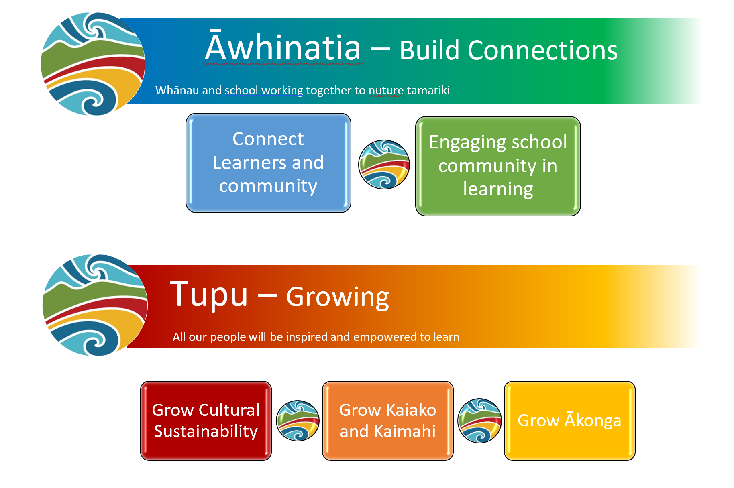

All of our Annual Goals aim to: Accelerate the achievement of all tamariki, especially Māori and Pasifika; Continually develop teaching pedagogy through professional development; Raise the achievement of students with special learning needs, and support students with special abilities to broaden/extend their progress; Continually develop student health and wellbeing, and the school learning environment; Engage families and develop home/school relationships.

Waiho i te toipoto, kaua i te toiroa
Āwhinatia – Build Connections
Whānau and school working together to nuture tamariki
Waiho i te toipoto, kaua i te toiroa

Whāia te mātauranga hei oranga mō koutou
Let us keep close together, not wide apart
This whakatauki speaks to the importance of keeping connected, of maintaining
relationships and dialogue so that we can keep moving forward together.
2024- 2025  NELP 1/1 Learners at the Centre, NELP 2/3 Barrier Free Access, NELP 3/6 Quality Teaching and Leadership | Initiative | Inputs | Activity | Outcome | Measure | People
 | Connect Learners and Community | Board | BoT works in partnership with whānau Māori in planning, decision making and resource management | BoT understands the way iwi, hapu, and whānau Māori want to work with boards.  BoT understand tikanga, te reo and local pūrākau. | Whānau Māori korero | Board of Trustees
 |  | Planning days  CRT  ToDs | Design programmes of learning that offer community opportunities.  BoT proactively seek to understand the aspirations of the Māori community and these aspirations are acted on | Programmes of learning planned with community in mind  Opportunities for whānau Māori to feed into school decision making | Teams analyse each term and review planning  BoT seek feedback to ensure there is enhanced whānau Māori self-determination and mana Motuhake (meaning)  Analyse the number of EOTC events planned that meet the requirement. | Kaiako  BoT
 |  | Planning days  CRT | EOTC activities planned from beginning of year to support connections with iwi, hapu, whānau Māori | Providing opportunities for our tamariki to access resources relating to local iwi, hapu, whānau Māori |  | Principal  DPs  Kaiako
 | Engaging school community in learning | Release time 0.1 per associate leader (Budget)  1 Unit per team leader (MoE)  1 unit ICT | Website update  Videos of pedagogy posted on HERO and website | Community fostered to participate in collaborative partnerships for learning. | Whānau survey mid 2022, 2023, 2024 | Associate Leaders  DPs  Principal  ICT unit holder  Kaiako
 |  | HERO subscription  Hero Unit | Set up of HERO for ease of access  Pop up HERO info sessions | Whānau able to access information required |  | DPs  Principal  Unit Holder
 |  | PD: Communication skills  Hui | Targeted, timely communication  Review ‘Learning Conversations’  Seek to understand the aspirations of whānau Māori. | Whānau are informed of learning, information and events appropriately  These aspirations are acted on |  | All kaiako
 |  | DP release  HERO unit | Kaiako available before school during Connection Time  HERO, Zoom  Phone calls / emails home  Pop up info sessions  Planned info sessions | ‘Open door’ encouraged so  whānau have wide range of opportunities to engage | Analyse engagement across platforms used | DPs  Kaiako  Principal

Whāia te mātauranga hei oranga mō koutou
Tupu – Growing
All our people will be inspired and empowered to learn
Whāia te mātauranga hei oranga mō koutou

Seek after learning for the sake of your wellbeing
This whakatauki refers to the importance of learning for it is key to your wellbeing. If
you follow the path of learning, the world will be your oyster.
2024 – 2025  NELP 1/2 Learners at the Centre, NELP 2/3, 2/4 Barrier Free Access, NELP 3/5 Quality Teaching and Leadership, NELP 4/7.1,7.2 Future of Learning and Work | Initiative | Inputs | Activity | Outcome | Measure | People
 | Grow Cultural Sustainability | Release time | Use Culturally Responsive practices framework to guide planning | Culturally sustainable practice embedded | Teacher planning  Observations | Associate Leaders  DP’s  BoT
 |  | Kura Ahurea  Release time | Attend Kura Ahurea PD, share across staff | Tamariki, kaikao, kaimahi understand tikanga, te reo and local pūrākau. | Tamariki korero | Two Kaiako - Toa  Kaiako  BoT
 |  | Māori Achievement Collaborative https://www.mac.ac.nz/ | Principal to be part of MAC | Greater understanding of leadership practice for Māori success | Improved Māori achievement | Principal
 | Grow Kaiako and Kaimahi | Professional learning (budget)  WSL – Kāhui Ako | Longworth Education  BSLA | All staff to have understanding of Learning Through Play Pedagogy  Yr 0- 2 kaiako develop skills in structured literacy | Practice Implementation Checklist  BSLA assessment | WSL  Kaiako  Kaimahi
 |  | PD: WSL – Kāhui Ako  ToD  Staff/ Team meetings | Collaborative planning and teaching; research through readings, workshops, visits  Hub Vision updates | Effective Teaching and Innovating practice | Collaborative Planning in OneNote  Observations | WSL  Kaiako
 | Grow Ākonga | Unit | Connect tamariki with community through electives | Tamariki have opportunities wider than school | Tamariki korero | Unit holder  BoT  Kaiako
 |  | Release time 0.1 per associate leader (Budget)  1 Unit per team leader (MoE)  DPs  WSL – Kāhui Ako | Pūmanawa-ā-ākonga development  Literacy and maths goals reviewed | Tamariki understand goals including Pūmanawa-ā-ākonga, can use goals to support tamariki to Waihangatia ngā ākonga tino pai | HERO analysis  Tamariki korero | Kaiako  Associate leaders  DPs
 |  | Release time 0.1 per associate leader (Budget)  1 Unit per team leader (MoE)  DPs | PD in play based learning.  Continue building understanding of learner agency  PD in Structured Literacy | Effective and innovative teaching and learning for tamariki to grow | Tamariki korero  Learner agency: Can students…  http://nzcurriculum.tki.org.nz/Curriculum-resources/NZC-Online-blog/Learner-agency | Kaiako  Associate leaders  DPs

Lyall Bay School Strategic Aims Overview Timeline 2023-2025

Āwhinatia – Build Connections
Whānau and school working together to nuture tamariki
Waiho i te toipoto, kaua i te toiroa

2024 - 2025 | Initiatives | Timeline  2023 2024 2025
 |  | Term 1 | Term 2 | Term 3 | Term 4 | Term 1 | Term 2 | Term 3 | Term 4 | Term 1 | Term 2 | Term 3 | Term 4
 | Connect Learners and Community |  |  |  |  | BoT works in partnership with whānau Māori |  | Programmes of learning planned with places in our community in mind | Website updated | EOTC planned that supports iwi, hapu, and whānau Māori
 | Engaging school community in learning |  | Kaiako make pedagogical videos  Website updated |  | Website reviewed |  | Kaiako make pedagogical videos |  |  |  | Pedagogical videos on website to support whānau understanding
HERO pop up info sessions, in person, via zoom
HERO use reviewed

Hui to understand aspirations
 |  |  |  |  | Set events for year |  |  |  | Review ‘Learning Conversations’ | Set events for year
 |  |  | Set events for year |  |  |  |  |  |  |  | Review Learning conversations
 |  |  |  |  | Open door, Kaiako available on email, phone, zoom, gate, in person. Hui, info sessions
Tupu – Growing
All our people will be inspired and empowered to learn
Whāia te mātauranga hei oranga mō koutou

2024 - 2025  2024 - 2025 | Initiatives | Timeline  2023 2024 2025
 |  | Term 1 | Term 2 | Term 3 | Term 4 | Term 1 | Term 2 | Term 3 | Term 4 | Term 1 | Term 2 | Term 3 | Term 4
 | Grow Cultural Sustainability |  | Share Research on Culturally Responsive Practices |  |  |  |  | Develop LBS framework with Kura Ahurea |  |  | Hui with whānau Māori: analyse and ensure aspirations are included in planning
 |  | PD: Resources from Kura Ahurea to support tikanga, pūrakau and te reo
 |  |  |  |  |  |  |  | Leadership through Maāri Achievement Collaborative
 | Grow Kaiako and Kaimahi |  | Collaborative protocols in place |  | Longworth Education PD | BSLA PD Yr 0-2 kaiako |  |  |  |  | Continue to embed LBS pedagogy to empower staff and ākonga
 | Grow Ākonga |  |  | Whānau input for electives | Communityinput for electives | Kaiako develop Pūmanawa-a-ākonga process  Electives offered across school to enhance tamariki interests and aspirations  Collaborative PD to enhance teaching and learning | Tamariki interests | Whānau input for electives |  | Use Community data base
 |  | Kaiako review use of goals |  |  |  |  |  |  |  | Programmes developed using Learning Through Play and Learner Agency pedagogies | Kaiako develop goal setting framework to support tamariki

2024 Annual Plan
2024 | Strategic Initiatives and measure | Term 1 | Term 2 | Term 3 | Term 4
 | Connect Learners and Community: | Kaiako plan using community input, review ‘places’ regularly |  |  | BoT works in partnership with whānau Māori in planning, decision making and resource management
 | Engaging school community in learning: whānau survey mid 2022, 2023, 2024 | Website reviewed | HERO pop up info sessions available. Recorded and put on Website.  Kaiako pedagogical videos for website
 |  |  |  | Hui with whānau Māori: analyse and ensure aspirations are included in planning
 |  | Mihi  whakatau  W.A.T.P  sess  Behaviour survey  Events on calendar | Connection time available for whānau every morning  W.A.T.P  Wk 3 | W.A.T.P  wk 3 | W.A.T.P  wk 3
 | Grow Cultural Sustainability: teacher planning and observations | Share current practice | Kura Ahurea guide for te reo, tikanga and Pūrakau
 |  |  |  | Leaders use Poutama Reo and Niho Taniwha to support growth in kaiako with support from MAC
 |  | MAC: Improved outcomes for Māori through leadership PD
 | Grow Kaiako and Kaimahi: observations etc | Hub collaborative protocols set |  | Structureed Literacy PD (BSLA) for Huetepara  Learning Through Play PD:PBlot observations and feedback to continue to develop practices and pedagogy for Maranui and Onepū
 | Grow Ākonga | Electives across school | Tamariki input sought  Whānau input sought
 |  |  | Kaiako develop goal setting framework to support tamariki, goals set each term, shred via Learning Conversations term 1 & 3, and via HERO terms 2 & 4 | Whānau input sought
 |  |  | Design for learning developed collaboratively using Learning Through Play and Learner Agency pedagogies

Whakatauki sourced through inspiringcommunities.co.nz

