Attendance
Attendance is when learners are at school and in the class they are supposed to be in. If learners miss a week or more of school in a term they have ‘non-regular attendance’. Learners who miss a week each term will have missed out on a year of schooling by the time they are 16.
Given what we know about what drives attendance along with international evidence on what is effective, the three key actions schools can take are:
- increasing parents’ awareness and expectations
- making learning engaging and school a great place to be
- identifying and tackling specific barriers.
1 - Increasing parents’ awareness and expectations
- Make sure parents know that attendance is important and set expectations accordingly.
- Make sure parents know how much their child is attending.
- Deliver these messages early and often.
Breakdown impact of attendance with achievement and relationships at school.
Include in newsletters.
Share attendance with whānau so they have a good sense on how much school their children are missing. Share attendance with those who are not attending at least once a term - mid term and follow up end of term with how they are going, by email.
. Making learning engaging and school a great place to be
- Create a welcoming environment.
- Promote positive relationships between teachers and learners.
- Get learners interested in what they are learning.
No bells – how do we come together?
Welcoming environments where all tamariki can ‘see themselves’ (breakdown of those whose attendance is low and can they ‘see’ themselves? What are their interests? Who are their friends? Who is their whānau?) Kaiako put this info on pastoral care. Each of these tamariki are flagged red for > 30%, blue for > 20%, green > 10 %. Open up attendance data to whānau on HERO.
How do they feel about school?
Strong relationships (use connection time)
- Identifying and tackling specific barriers
- Find out exactly what is making attendance more difficult.
- Develop responsive strategies for specific barriers.
- Work together with families/whānau.

2024 Data
Absence of more than 30% - 8 tamariki
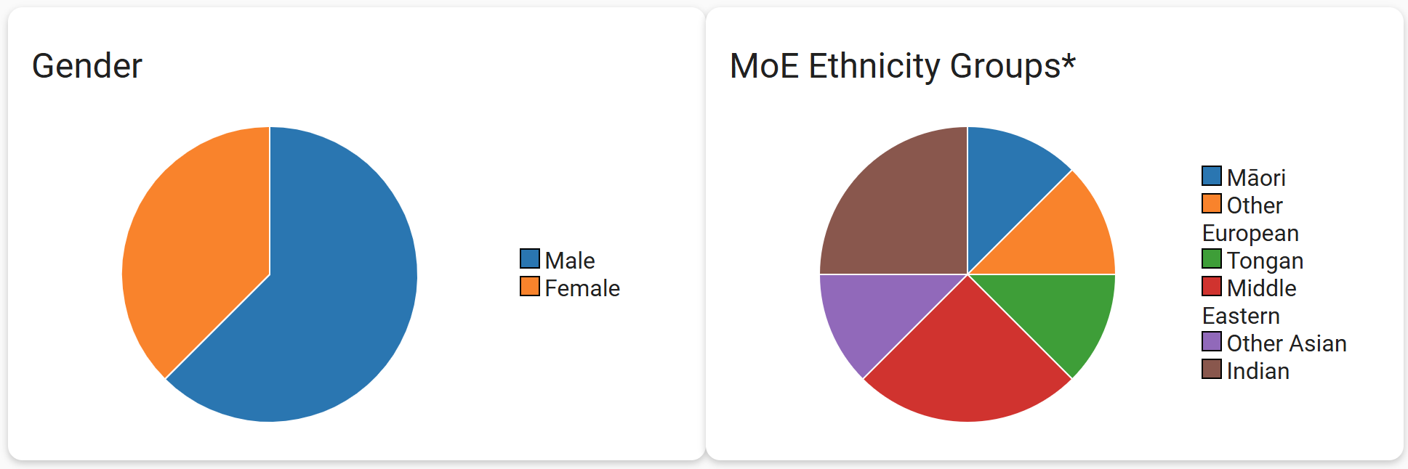
HP | 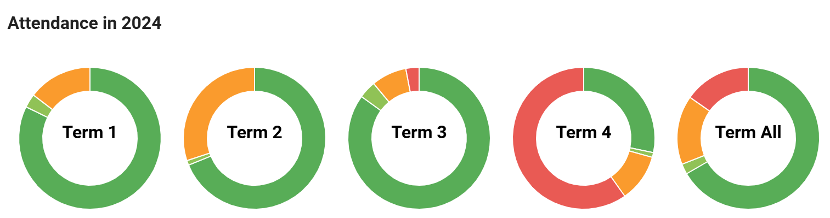 | Overseas to visit family in term 4
AD | 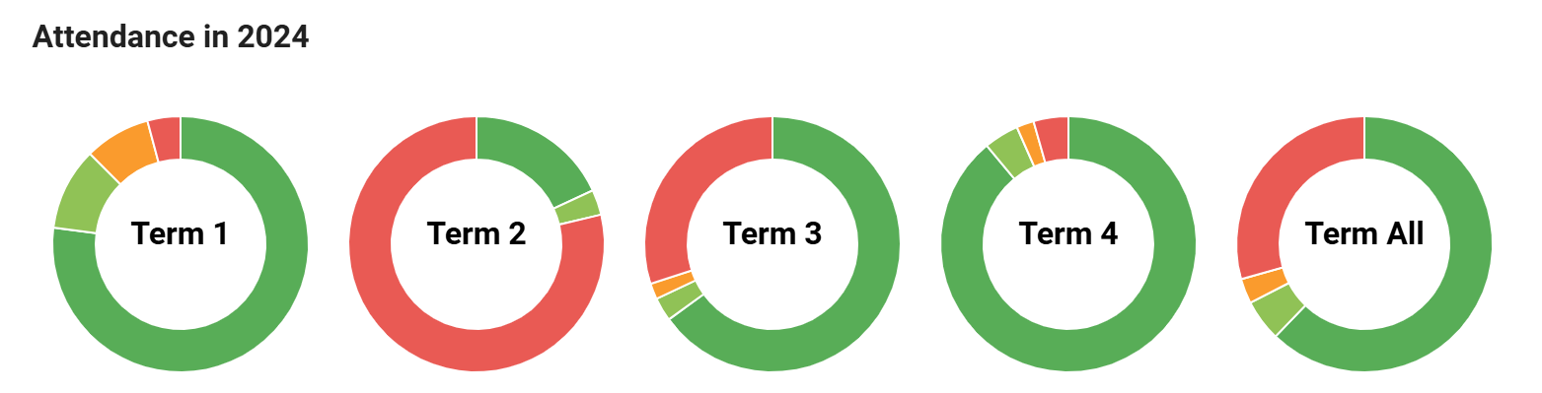 | Overseas to visit family in term 2 & 3
ZT | 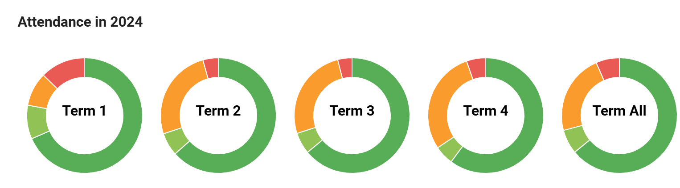 | Family circumstances – improved since a conversation with whānau
AM | 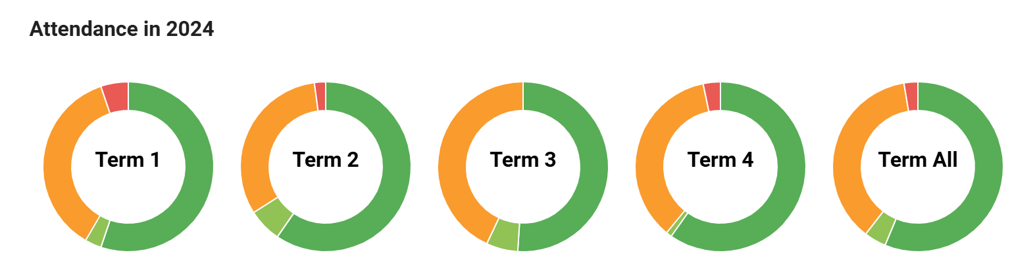 | ‘sickness’ – stress: contacted whānau
NU | 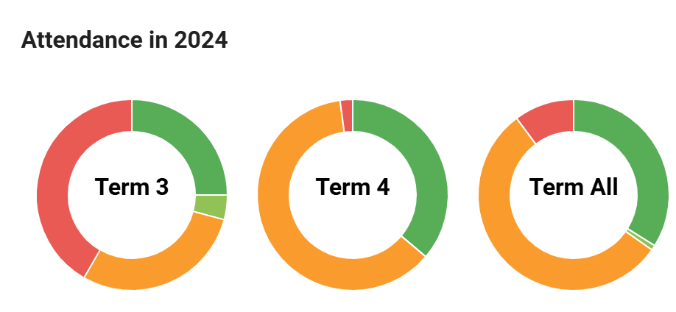 | Under MoE – short hours at school, medical condition.
EA | 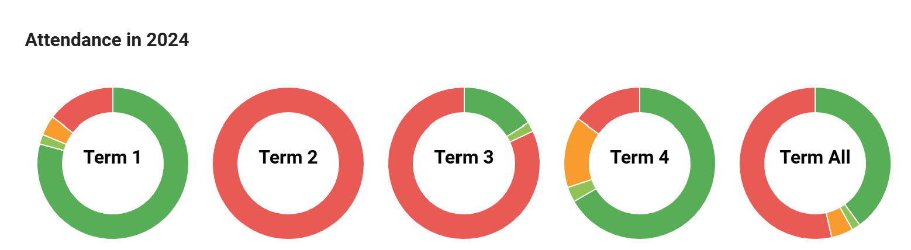 | Overseas to visit family term 2 & 3
HA | 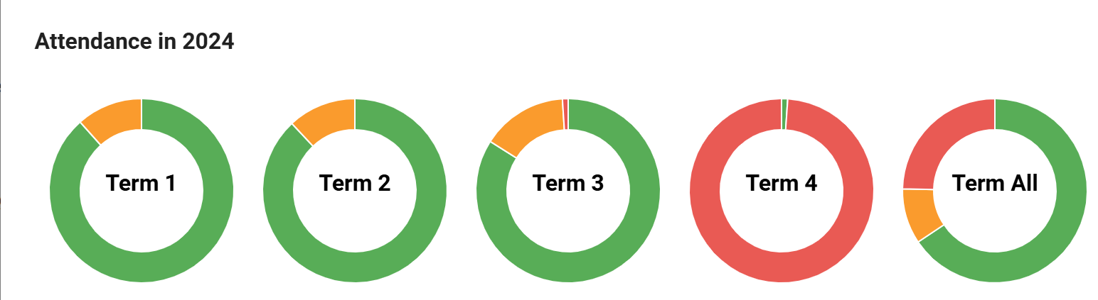 | Overseas to visit family term 4
AF | 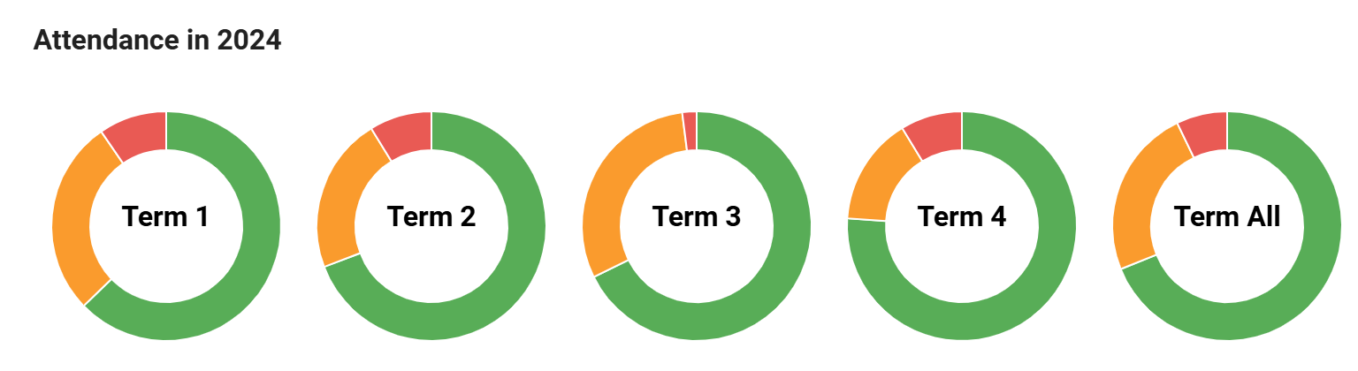 | Reported as unwell, or going somewhere with family.

Absence of more than 20 %
29 including 8 of more than 30 %
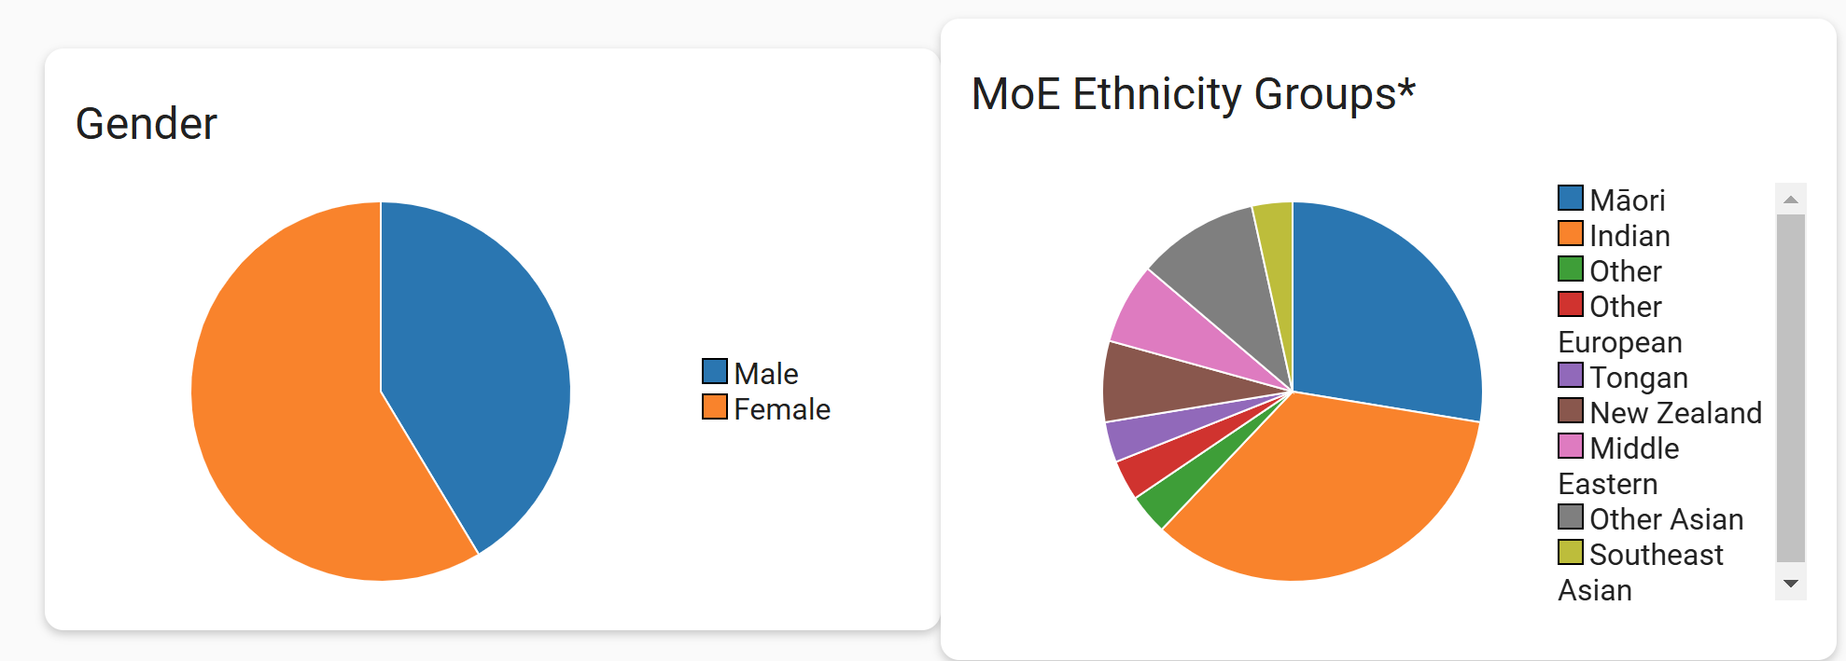
Reasons given are: Overseas holidays, whānau time (one family), sick, no explanation but home circumstances unstable, (one family, contacted), home circumstances (one family, conversation), visiting whānau overseas, funerals, religious holidays, family events/visits, family work circumstances, anxiety, sibling unwell, medical conditions, doctor appointments, hospital and recovery. No explanation from some.
Bolded reasons to be raised with whānau and in newsletter.
Absence of more than 10%
139 including 37 above
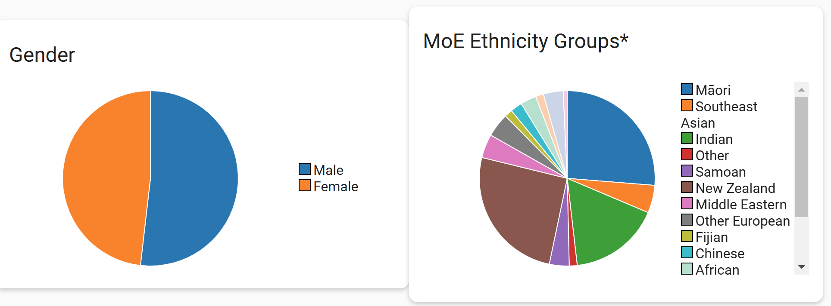
Reasons given: All of above as well as: lack of sleep, lack of food (contacted and sorted), long weekends, shopping, skiing, tired.
These will be considered in newsletters.

